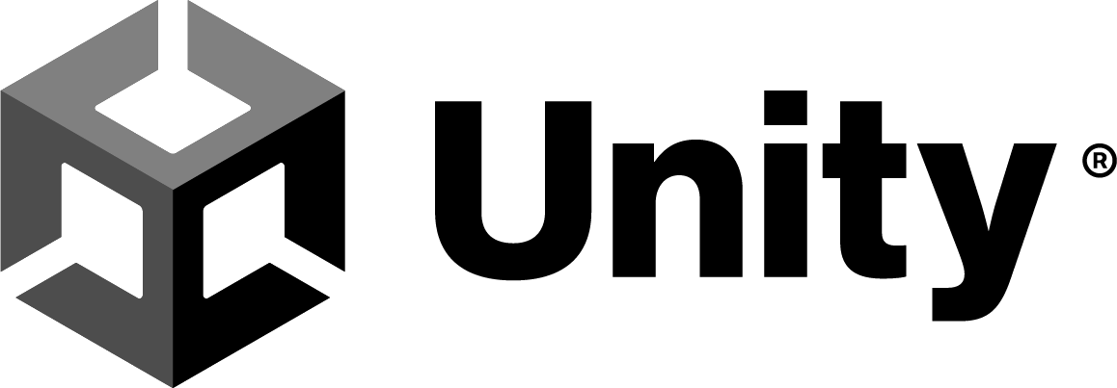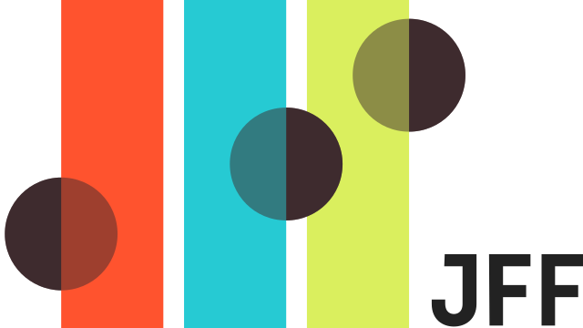

2023 Unity Workforce Grant
Apply by Jun 2, 2023
Please make a copy or download this document. Remember, applications must be submitted through Typeform.

Overview
We are thrilled to announce our open call for submission on April 17. We are excited to provide funding support for programs training real-time 3D developer talent for in-demand careers. Whether you are planning a new training program or need funding to expand your existing training program, please fill out this form. We’ll review all submissions and identify programs that fit best with our grant strategy.

Please share your ideas with us by June 2, 2023 at 11:59pm PT.

What We’re Looking For
The purpose of this grant is to support training programs upskilling students in real-time 3D — especially those in underrepresented communities — to have access to high-paying in-demand careers. You can learn more about what we fund and last year’s open call on our website.

Our Investment Criteria:
Career Development
- Project team explains their training model and curriculum to ensure graduates are job ready upon program completion.
- Project team identified hiring partners/potential employers for program graduates.
Diversity & Inclusion
- The program reaches learners from underrepresented populations.
Impact
- The program has high demand and sets clear goals for the number of learners that will complete the training program.
Viability
- The program shares a clear timeline, broken down by stages: planning, training, and reporting.

What We Offer
We accelerate your efforts by providing support in three key areas:
- Funding: A grant award up to $200,000 for each recipient, depending on the stage of the organization or idea.
- Communities of practice: Opportunities to build relationships with and learn from other leaders who are doing similar work.
- Management assistance: Access to relevant, timely and customized support from our team and external experts.

Timeline
Application opens: April 17, 2023
Application closes: June 2, 2023 at 11:59pm PT
Finalist interviews: July 17-28, 2023
Funding decisions: By August/September 2023

Application Questions
You can find a copy of the application questions and instructions below for your reference. Please make sure to submit responses in Typeform by Friday, June 2 at 11:59 pm PT. For any support needs, you can submit your question via email: socialimpact@unity3d.com

Please note that the 250 words limit for the long text responses are limited to 1,250 characters each.

Contact Information
- 1. First and Last Name
- 2. Pronouns
- 3. Program role/title
- 4. Email address
Organization Information
- 5. Organization or program name
- 6. Organization or program website
- 7. Region
- 8. Location (State/Province, Country)
Program Information (Description: If your submission is for a joint program across 2 or more organizations, please answer the following questions based on the organization acting as the prime/lead.)
- 9. What best describes your program?
  - Nonprofit organization
  - Higher education institution
  - For-profit organization with educational training
- 10. Tell us about your program. (Description: What is your mission? What does your program do? What are your core program activities? Tell us about your program team?) (250 words)
- 11. Program logline: Please describe what your program does in 50 words or less.
- 12. Tell us about your training model and how you assess skill mastery for your learners? Are you currently using Unity Learn in your curriculum? If applicable, what are your historical outcomes on program completion and job placement rates for your program (or the most similar program if this is for a new program)? If you have other outcomes you’re proud of, please share it here. (250 words)
- 13. Tell us about who you've identified as potential employers or hiring partners for your learners. How have you engaged with these potential employers or hiring partners? (250 words)
- 14. Who does your program intend to serve? How are you recruiting and supporting learners from underrepresented populations? Include demographics and geographic reach data, if applicable. Please include % breakdowns (or approximations) as available. (250 words)
- 15. What is the estimated number of learners who will directly benefit from this program during your proposed timeline? (Numeric field; no text)
- 16. What is your projected timeline for this program? If possible, please break your timeline into planning, recruiting, training, and reporting. (250 words)
- 17. What is the estimated job placements rate for your learners within 12 months of program completion? (Numeric field; no text)
Grant Information
- 18. What is your program budget?
- 19. Please outline your plan for how you intend to use this grant. (250 words)
- 20. Have you received any funding for this program, if so what is the budget gap you would need with Unity’s support?
- 21. If available, please upload any relevant program decks or images as a PDF file here.
Technical Information
- 22. What version of Unity are you working with in this program? (If applicable)
- 23. What Unity license are you using in your program? (If applicable)
- 24. If you used a real-time 3D game engine other than Unity, what did you use? (If applicable)
Terms and Policies
- 25. I have read and agreed to the 2023 Unity Workforce Grant Terms and Conditions.
  - Yes/No
- 26. I acknowledge the Unity Privacy Policy [Republic of Korea Residents agree to the Unity Collection and Use of Personal Information]
  - Yes/No
- 27. (Optional) I agree to have Marketing Activities directed to me by and receive marketing and promotional information from Unity, including via email and social media.
  - Yes/No

